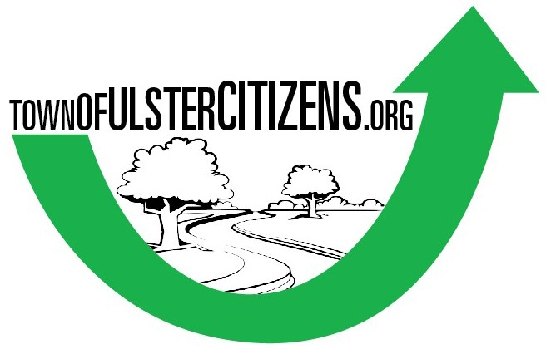
TownOfUlsterCitizens.org is a non-partisan, citizen-run organization focused on increasing citizen engagement and creating a better Town of Ulster NY.

January 8, 2024

To: Ulster County Planning Board
From: Laura Hartmann (Chair of ToUC.org), Town of Ulster
townofulstercitizens@gmail.com
Re: Lightstar Solar, Whitestone Development

Good evening, members of the Ulster County Planning Board:
On behalf of TownofUlsterCitizens.org, thank you for the opportunity to speak tonight.
Regarding the solar farm and the luxury development projects proposed on tonight's agenda, TownOfUlsterCitizens.org supports the installation of solar panel projects, and the environmental benefits of solar energy which includes cost savings to customers, and the tax base these projects can provide to our town. However, our town has plenty of commercial rooftops, parking lots and vacant parcels on which to locate solar panels without the need to fell a forest.
Our current comprehensive Plan (2007) specifically states the Town of Ulster should “provide greater protection of ridgelines from inappropriate development.“
From an environmental hazard perspective, these two projects proposed for that very ridge will have immediate effects, including:
• Massive wildlife decimation, including endangered species habitats by deforesting 24 acres of land,
• Rain run-off from deforestation and solar panel surfaces onto Tuytenbridge Road and Route 9W;
• Polluted wetlands and soil erosion from the panel installation affecting our water table;
• An increase of greenhouse gases currently captured by the existing forest; and the insulting ill-logic of providing clean and renewable solar energy at the expense of a forest that already sequesters carbon that the developers seek to obviate.
Additionally, residents' health and quality of life will be compromised by 600 additional cars driving up that ridge to the proposed luxury townhome project by Whitestone Developers. This will create standstill traffic along 9W and more pollution from exhaust fumes concentrated at that intersection, with less forest to help sequester those emissions.
We can barely get into the Adams parking lot as it is now. Neither of the recent traffic and mobility studies done at this intersection by the Town or Whitestone Development Partners take into account peak shopping at Adams Fairacre Farms or overnight guests coming and going at the already approved 100-room hotel soon to be built on the opposite side of this intersection feeding 9W and 209. How will this congestion affect Emergency Response time?
And, let us not forget that there are already 800 housing units already approved at iPark87, just down the road, less than a mile away. How many more people and cars are we going to put in this very small area? For the record, we support, and have always supported, the building of these 800 units because they are planned as affordable housing.
We urge the Planning Board to recommend that the Town of Ulster resolutely reject both of these proposals based on the cumulative physical impacts they will have on the town and its citizens. Whitestone Developers will profit and further exacerbate our affordable housing crisis and Lighstar Renewables will profit for 25 years (the useful life of current PV panels) after which our town is left with a decimated forest that was once a vibrant part of that ridge.
If all of these projects are built, that part of the Town of Ulster will be untenable. Who will want to go there?

Thank you for giving me this time to speak.
Thank you.

